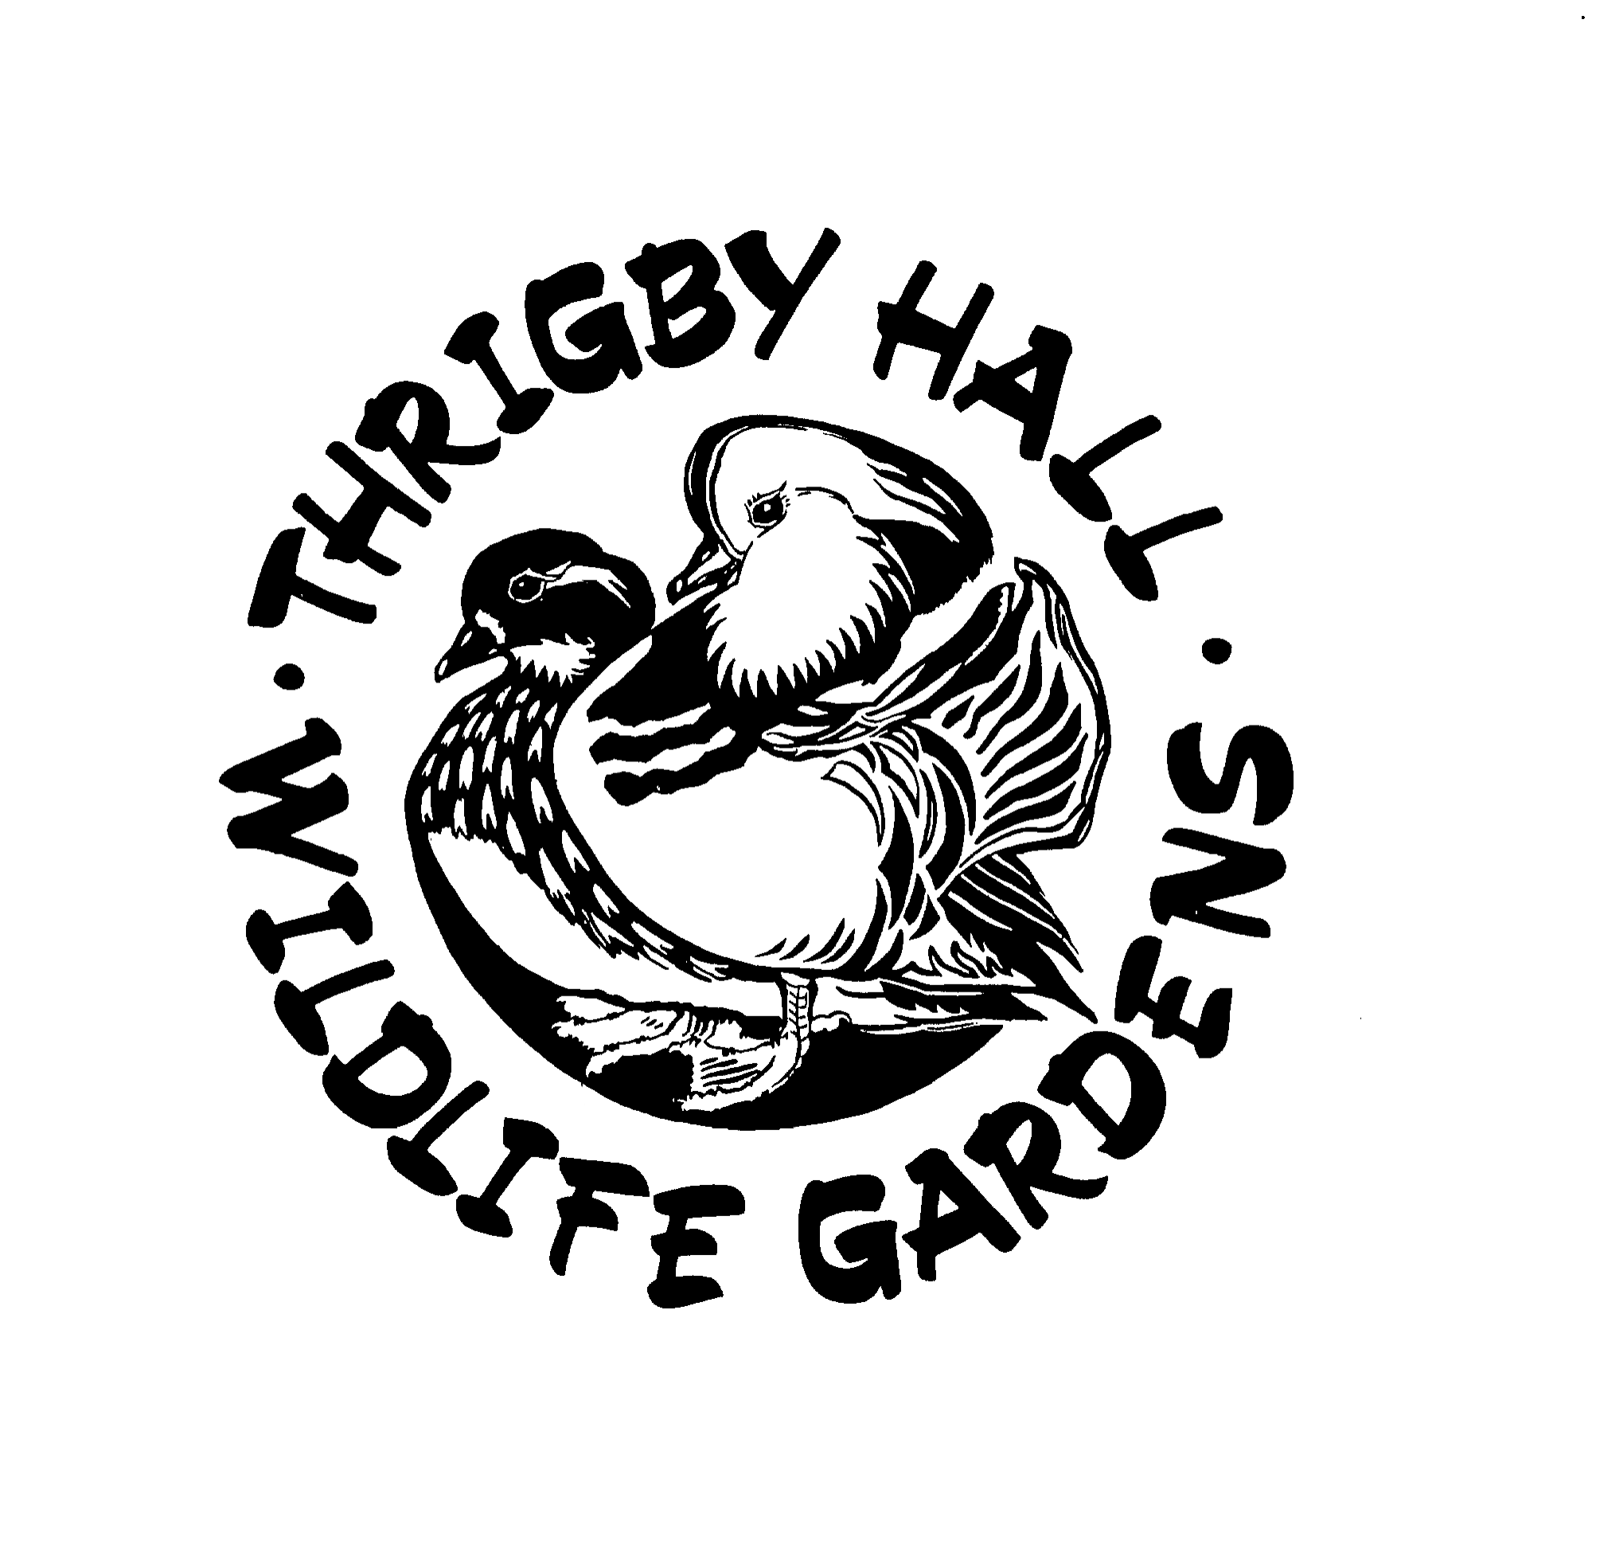
Job Description
- Job title: Catering & Retail Assistant
2. Department/Section: Catering & Retail
3. Main purpose of job: To support the effective and efficient running of the catering and retail facilities at Thrigby Hall Wildlife Gardens. Provide excellent customer service to customers. Greet customers at the entrance kiosk and use the till system to process guest entries to the park. Work in the cafe taking orders, processing payments, serving food and maintaining a high level of cleanliness. Assist in the gift shop selling retail stock and ensuring a friendly and welcoming shop environment. Work with other staff to ensure all visitors receive high standards of customer service.
4. Key result areas/key tasks/main duties:
- To provide a confident and efficient customer service and to ensure the entrance kiosk, cafe and shop environment at Thrigby Hall Wildlife Gardens is welcoming, presentable and safe at all times.
- To welcome visitors to the park, serve customers and help with any enquiries.
- Process sales and ticket bookings through the till, taking money and issuing change. Maintain a high level of accuracy and security.
- To participate in stock checks and ordering procedures, place orders, accept and check deliveries & invoices. Deal with any shortages or other problems.
- Develop and maintain a good knowledge of the products on offer and advise customers on their choices.
- To ensure daily checks and opening and closing procedures are carried out as instructed and that all health and safety procedures are followed.
- Serve food and drinks to customers whilst maintaining exceptional levels of food hygiene.
- To maintain high levels of personal hygiene and a professional appearance.
- Undertake any other duties deemed reasonable by your Manager.
5. Responsible for staff/equipment: Ensure that all equipment is used and maintained in accordance with relevant instruction. Also ensure that all equipment that you use is kept in good working order, is well maintained and is stored suitably.
6. Responsible to (reporting relationship): Zoo Director & Retail Manager

